+91 9340664893

Anubhav Singh

SOFTWARE ENGINEER
Anubhavsingh0003@gmail
.com www.linkedin.com/in/Anubh av Singh

Bhilai, Chhattisgarh

https://github.com/Anubhav
2021

SUMMARY
A motivated individual with in-depth knowledge of languages and development tools, seeking a position in a growth-oriented company where I can use my skills to the advantage of the company while having the scope to develop my own skills.

TECHNICAL SKILLS
Programming languages: C++, Java, Web Technologies:
Rest, J2EE, HTML5, CSS
Nodejs

Data Management:
MySQL, MS Access

CERTIFICATIONS

Learn c ++ program Beginner to Advance |Coursera | Dec '22
Front-End Development |
Meta| June'23

POWER SKILLS
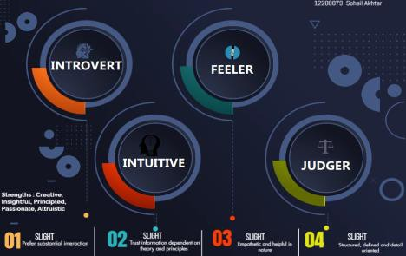

EXTRA CURRICULAR ACTIVITIES

A Competition on Digital
Presentation Feb'23

Memories to Talk- An Event on
Public SpeakingSkillsDec'22

INTERNSHIP

Software Engineering Intern Sep '22 - Nov '22

Chhattisgarh Infotech Promotion Society (CHIPS)| Raipur, IN

Front-End Development & Database
Gained hands-on experience in developing, implementing, and maintaining front-end applications.
Assisted the technical and team with the design, development, implementation, and
maintenance.
Learning how to write efficient database queries is a valuable skill. You could work on optimizing queries for better performance.

PROJECTS

Personal Portfolio Website Aug'22

Domain: HTML,CSS,Js, Bootstrap

Designed and developed a dynamic personal portfolio website using HTML, CSS, and JavaScript to showcase my skills, projects, and professional journey. The features an intuitive user interface and responsive design to ensure seamless viewing across various devices.
o Crafted an engaging "About Me" page that shares insights into my professional journey, work philosophy, and passion for
o Implemented a contact section to facilitate seamless communication, allowing visitors to connect with me for collaboration, inquiries, or networking.
MemoryGame Feb'22

Domain: JavaScript | Programming Languages: HTML, CSS, Java | Built a memory game using C++ and Javascript to test IQ Upgraded code to make the game error-free
Created HTML, CSS, JavaScript, and JSP pages for user interaction

ACHIEVEMENTS

• 4 Star Rating in C++ on Leet code Feb '23 - July '23

• Participate in Hackathon in college fest and secured 1st Position Nov’22

EDUCATION

B.Tech. in Computer Science Jul '20 - Present

CSVT University | Chhattisgarh, IN

CGPA7.75

Senior Secondary Examination Jun '18 - Mar '20

CBSE |Bhilai, IN

CGPA 8.4

